Lesson 30: Use Rancher
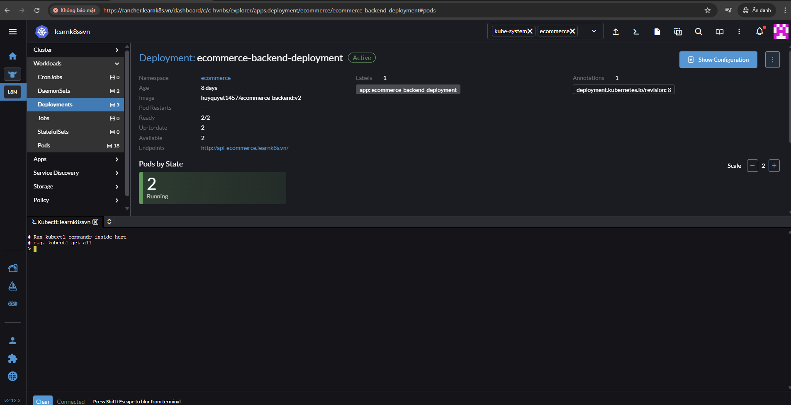
Kubectl shell tren rancher => khong phai la truy cap vao ben trong moi truong cluster cua k8s, ma la tao ra 1 container va container co the ket noi voi cum k8s qua API.
Cau hinh kubeconfig => giup cho 1 user khac co the truy cap duoc cum k8s, tren server la file .kube/config

Lesson 31. RBAC Rancher
- Standard User se duoc su dung trong 1 team nhu la dev, devops, system, co chut kinh nghiem => khong nen tin ai, accesst cho ai bat ky quyen, nen tao tai khoan, gioi han quyen tac dong => nen de Base User.
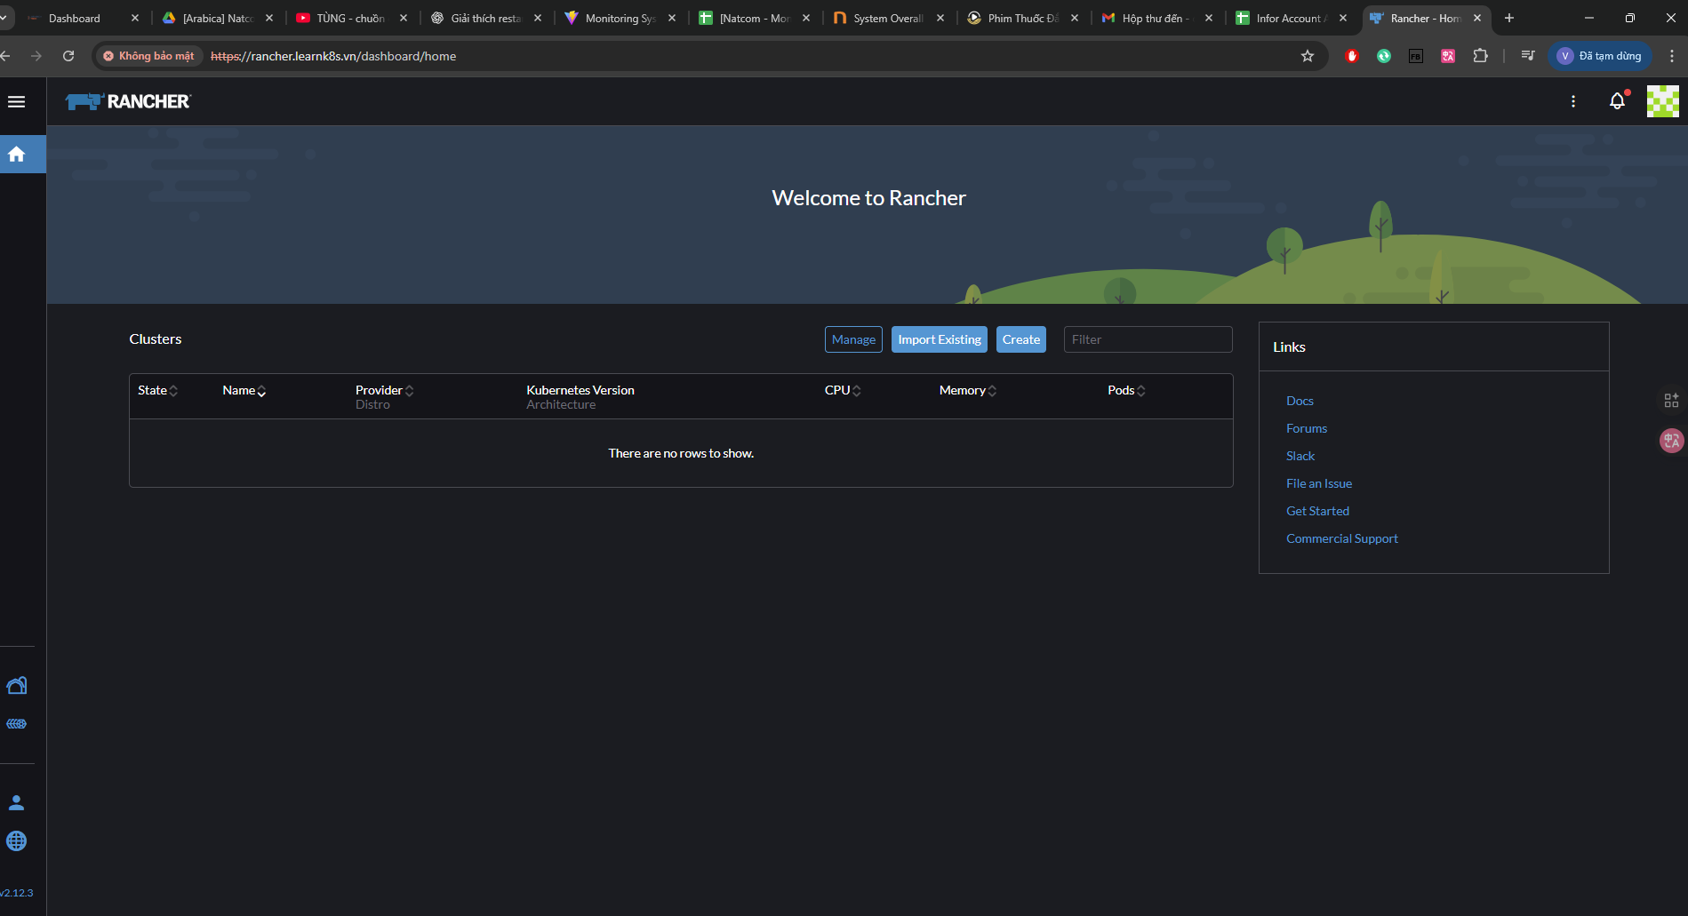
=> Khi vao bang quyen base user thi se khong co du an nao boi khong duoc quyen
=> Vao trong generic trong k8s tren rancher (learnk8ss) them user vao generic va co the custom quyen
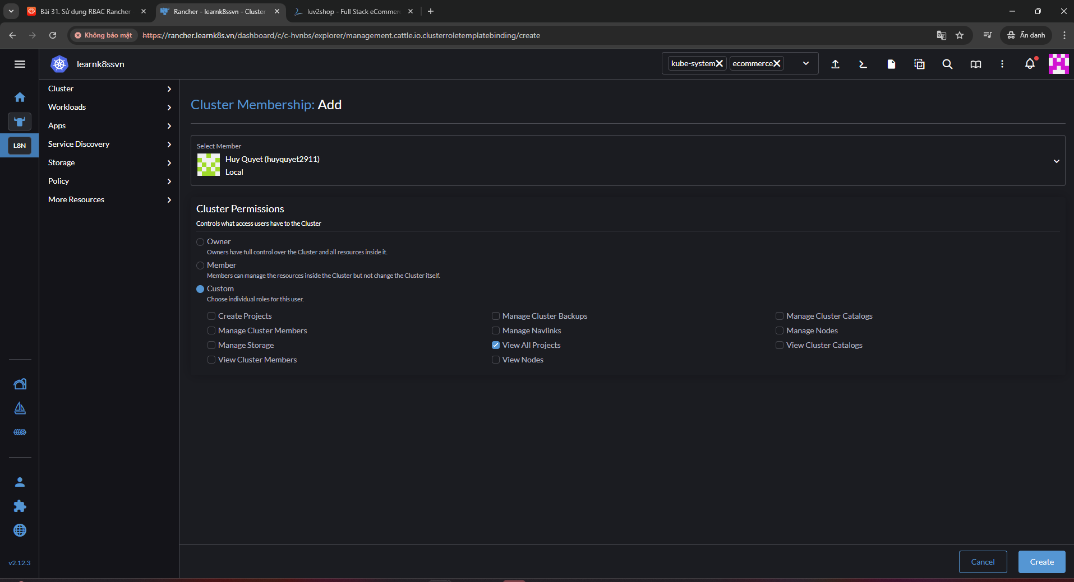
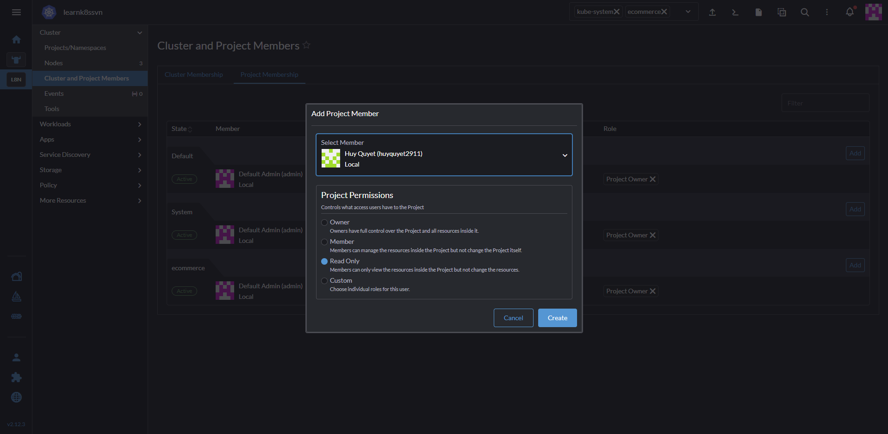
=> Co the add trong project va cac quyen

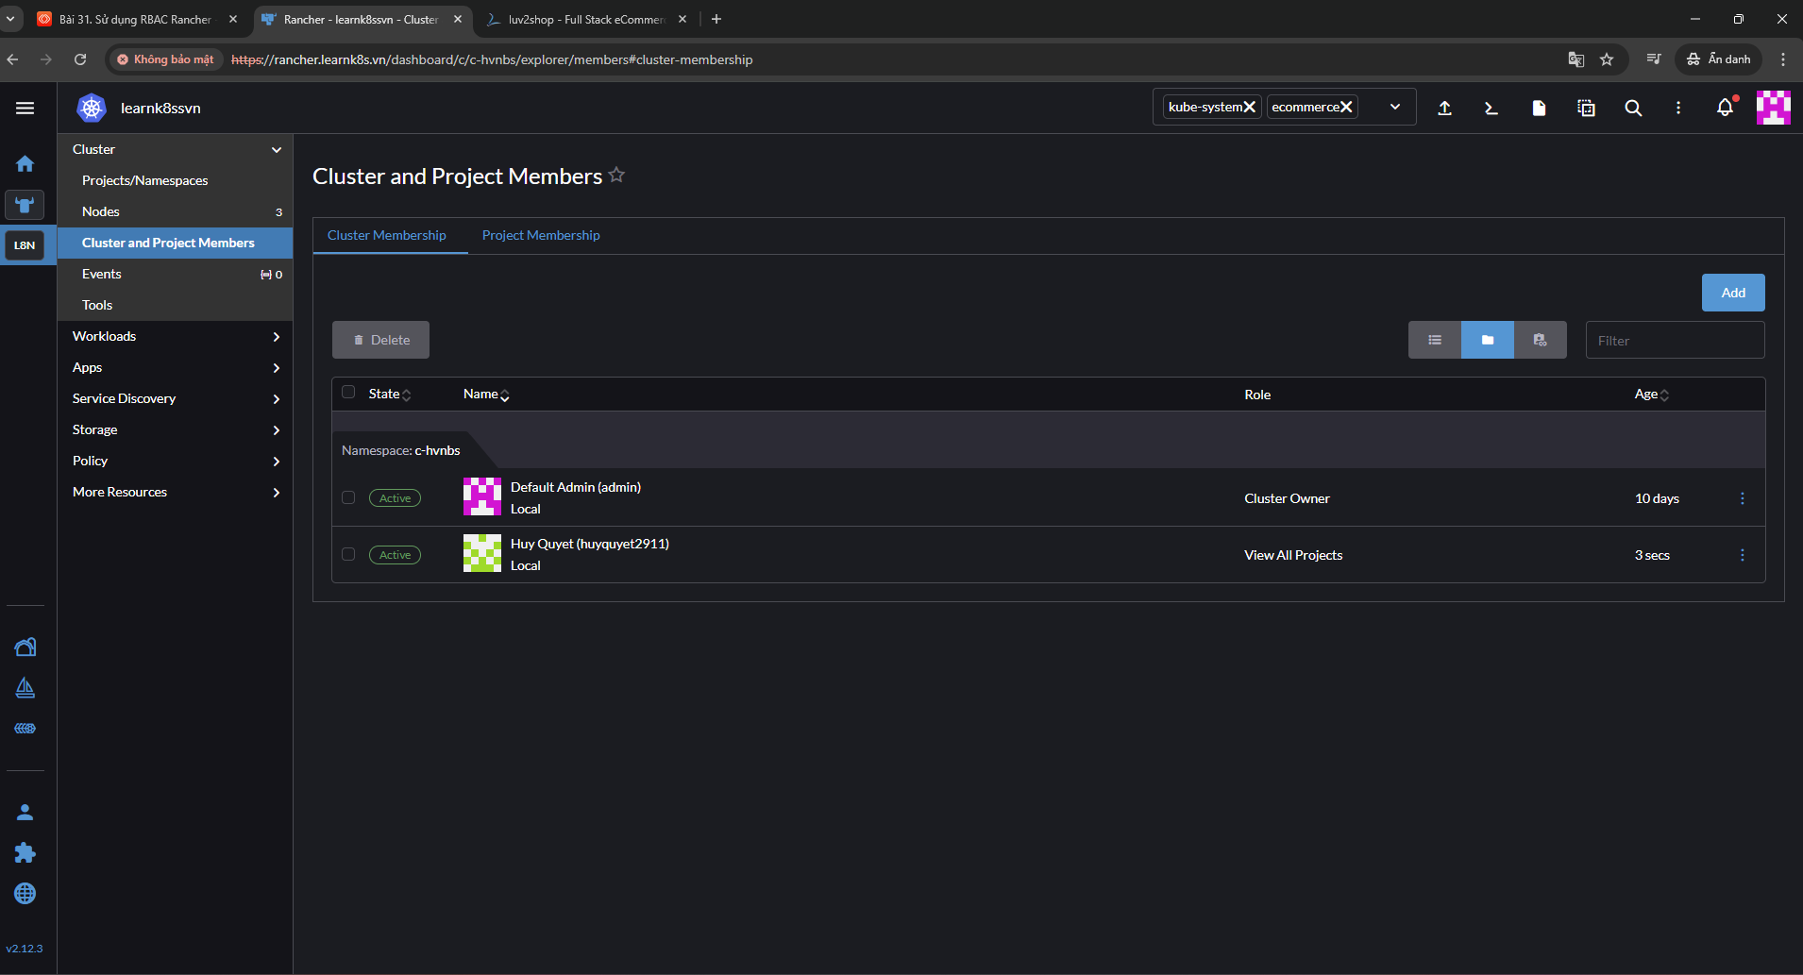
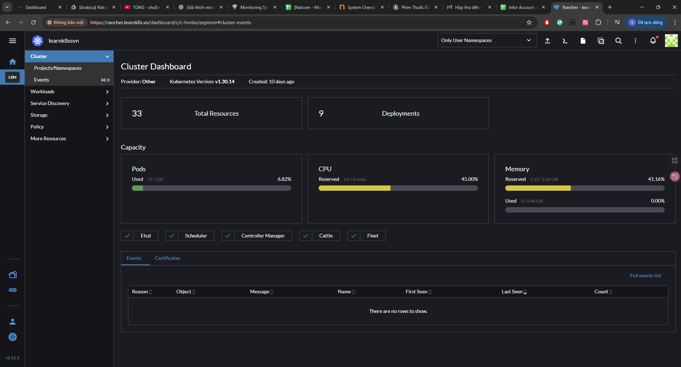
=> Khi them quyen view vao cluster and project member (cluster membership) thi user se xem duoc full total resources, deployment

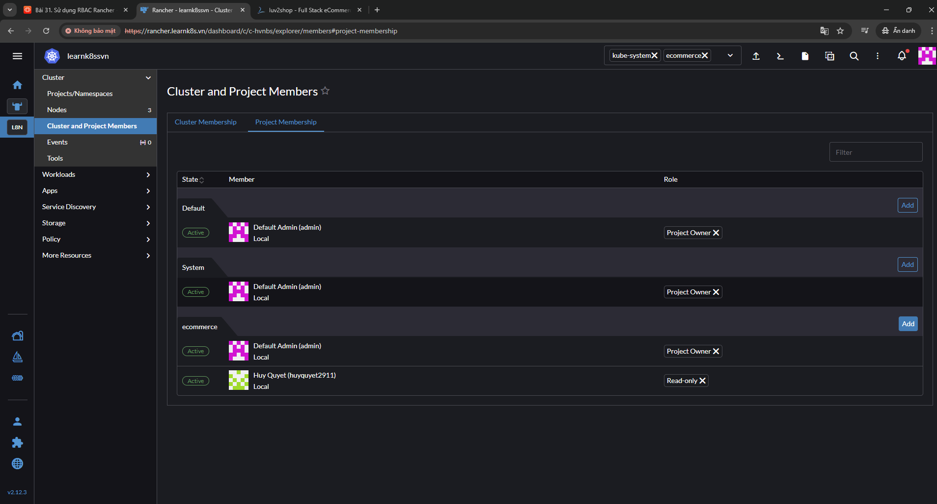
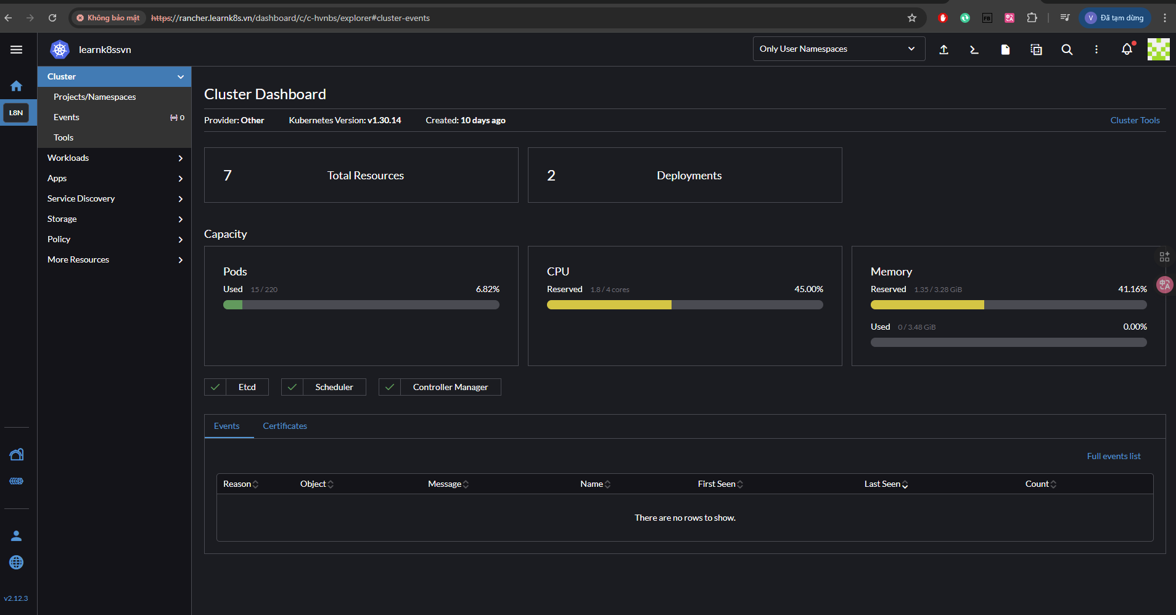
=> Khi them user vao cluster and project members (Project membership) thi se chi xem duoc cac toal resource, deployment cua project do thoi.

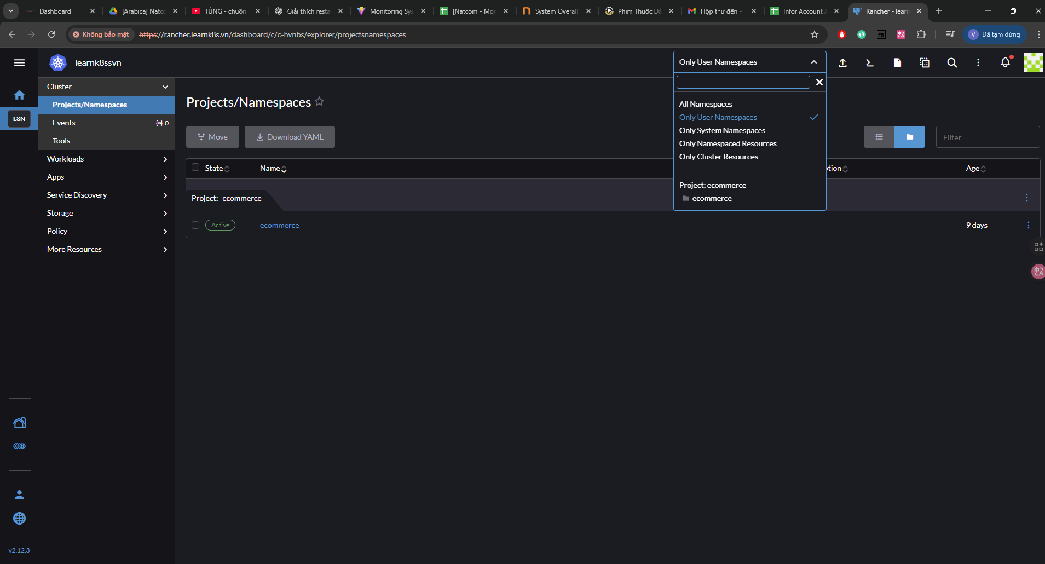
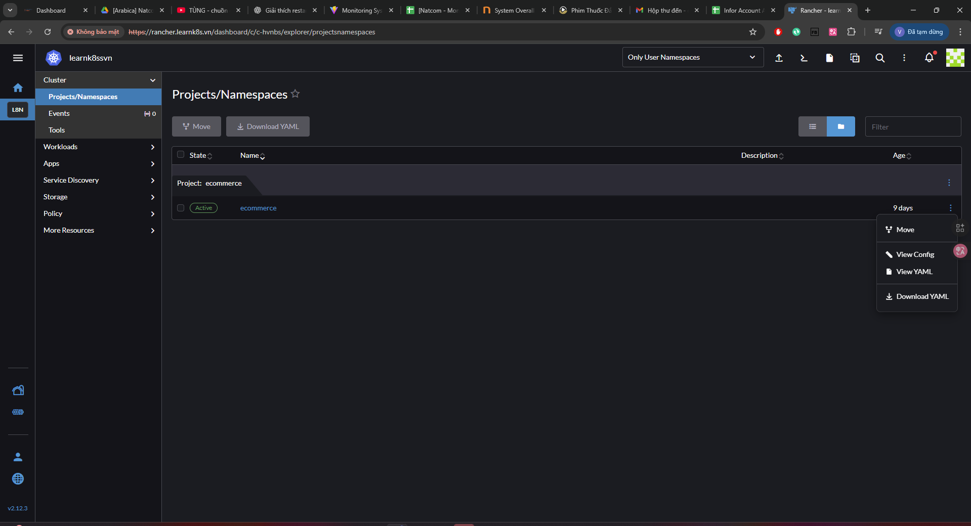
=> Vi chi duoc cap quyen view only nen chi view duoc thoi

